Task 8 – Aliaksandr Kudzelka

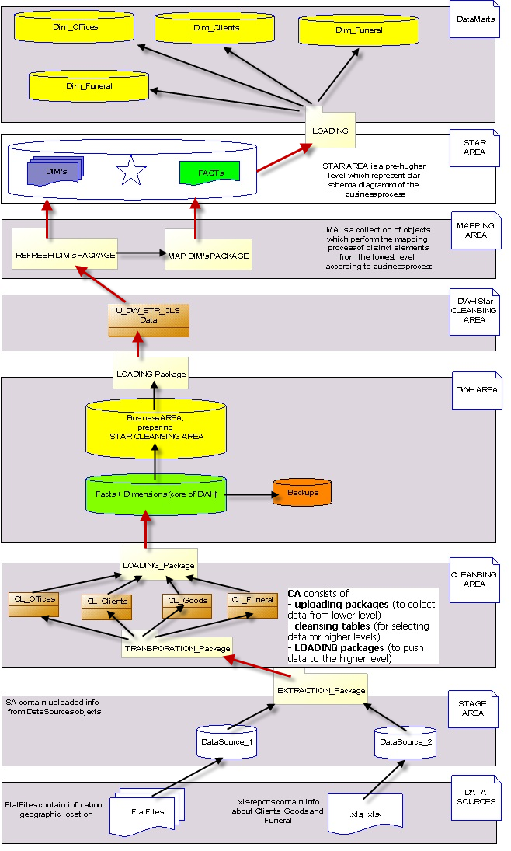

|  |  |  |  |  |
| --- | --- | --- | --- | --- |
| **Level Type** | **Object Name** | **Tablespace** | **Description** | **Privileges** |
| **Storage level**  **SA_\*** | U_SA_USERS | ts_sa_users_data_01 | Contains information in .xls-reports and FlatFiles | Create tables and views |
| **DW – Cleansing Level** | u_DW_cl_Offices | ts_dw_cl_offices_data_01 | Cleans raw data inserted from files and inserts it into tables according to the 3NF | Create and drop tables  Create and drop views  Select from SA views  Merge with SA views |
| u_DW_cl_Goods | ts_dw_cl_goods_data_01 |
| u_DW_cl_Funeral | ts_dw_cl_funeral_data_01 |
| u_DW_cl_Clients | ts_dw_cl_clients_data_01 |
| **DW – Level** | u_DW | ts_dw_data_01 | Stores information in the 3NF | Create and drop tables  Create and drop views  Select from DW-CL views  Merge with DW-CL views |
| **DW– Prepare Star Cleansing Level** | u_contr_dw_cl | ts_contr_dw_cl_data_01 | Creates views, which consist of merged tables from DW Level | Create and drop tables  Create and drop views  Select from SA-CL views |
| **STAR – Cleansing** | u_contr_cl | ts_contr_cl_data_01 | Deletes info, which doesn’t touch our business questions | Create and drop tables  Create and drop views  Select from Contr_DW views  Merge with Contr_DW views |
| **STAR Level** | u_FCT_Contracts | ts_star_fct_contr_data_01 | Stores information about facts | Create and drop tables  Create and drop views |
| u_DIM_Offices | ts_star_dim_offices_data_01 | Stores information about all dimensions | Create and drop tables  Create and drop views |
| u_DIM_Clients | ts_star_dim_clientss_data_01 |
| u_DIM_Funeral | ts_star_dim_funeral_data_01 |
| u_DIM_Goods | ts_star_dim_goods_data_01 |